Lab 01: Quartus Prime Tutorial

ECE 380-002

University of Alabama

Yichen Huang

Thomas Dillman

2019/08/26

**Introduction**

In this lab, I have got familiar with VHDL, a hardware description language, and Quartus Prime, CAD software. I have gone through three design methods in the CAD software, Quartus.

**Procedure**

1. Prelab

There was no prelab for this lab.

1. Setup and Data Collection

We followed the steps from the tutorial guide for the lab1.

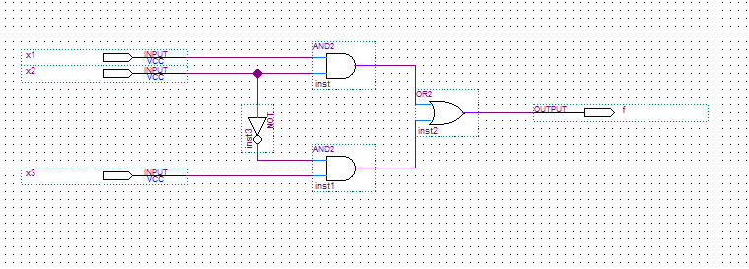Firstly, we create a new project named example_schematic. In the project, we create the Block Diagram File called example_schematic.bdf (Figure1). Then we compile the project and run the stimulation by creating a VWF file called A screenshot of a cell phone
example_schematic.vwf. (Figure2)

**0 -> 0 -> 1 -> 1**

**0 -> 1 -> 0 -> 1**

**0 -> 0 -> 1 -> 1**

**0 -> 0 -> 1 -> 1**

**Figure 1 example_schematic.bdf**

**1**

**1**

**0**

**1**

**1**

**1**

**1**

**1**

**0**

**0**

**0**

**0**

**1**

**0**

**0**

**0**

**Figure 2 example_schematic.vwf**

Secondly, we create the second project called example_vhdl. In this project, we create a VHDL file called example_vhdl.vhd. (Figure3) Then, we compile the file and run the stimulation step like the first project, the file name is example_vhdl.vwf. (Figure4)

**Figure 3 example_vhdl.vhd**

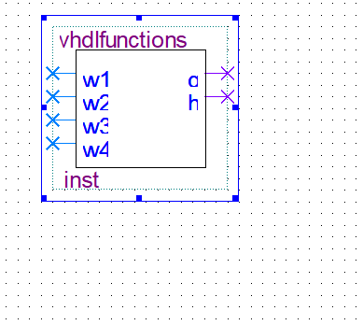Finally, we create the project named example_mixed1. In the project, we create a symbol called vhdlfunctions.bsf (Figure5) by coding a VHDL file called vhdlfunctions.vhd (Figure6). Then we create a block design file called example_mixed1.bdf (Figure7) and connect the circuits by the guide. After compiling, we A screenshot of a cell phone
create a file called example_mixed1.vwf (Figure8) to simulate the circuit.

**Figure 6 vhdlfunctions.vhd**

**0**

**0**

**1**

**1**

**0**

**0**

**1**

**0**

**1**

**0**

**0**

**0**

**0**

**0**

**0**

**0**

**Figure 4 example_vhdl.vwf**

**Figure 5 vhdlfunctions.bsf**

**X2: 0 -> 0 -> 1 -> 0 -> 0**

**W4: 0 -> 0 -> 1 -> 1 -> 0**

**W3: 0 -> 1 -> 1 -> 0 -> 1**

**F: 0 -> 1 -> 1 -> 0 -> 0**

**W2: 0 -> 0 -> 1 -> 1 -> 0**

**W1: 0 -> 1 -> 0 -> 0 -> 0**

**0**

**1**

**0**

**1**

**0**

**0**

**0**

**0**

**1**

**0**

**0**

**0**

**1**

**1**

**1**

**1**

**0**

**1**

**1**

**0**

**0**

**0**

**0**

**0**

**1**

**0**

**1**

**0**

**0**

**0**

**Figure 7 example_mixed1.bdf**

**Conclusion**

**Figure 8 example_mixed1.vwf**

During the lab time, we have learned that there are three ways to construct the circuit which are schematic, VHDL and mixed. In the lab, we also get familiar with the software.

**Afterword**

Attached is a copy of the sheet used to collect information during lab, which has the verification signature on it. (Figure 9)

**Figure 9 Lab Sheet**